Equifax – New Biz – Peter Sluckey at Marsh – 12/15 Effective Date
Opportunity is replacing Markel at 10 x 70 ABC – 80% ILF - $80,282
$1.5M LM Relationship
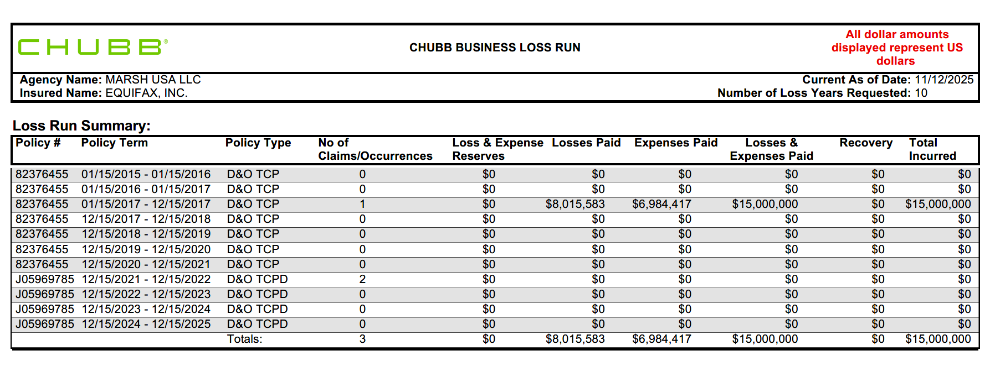
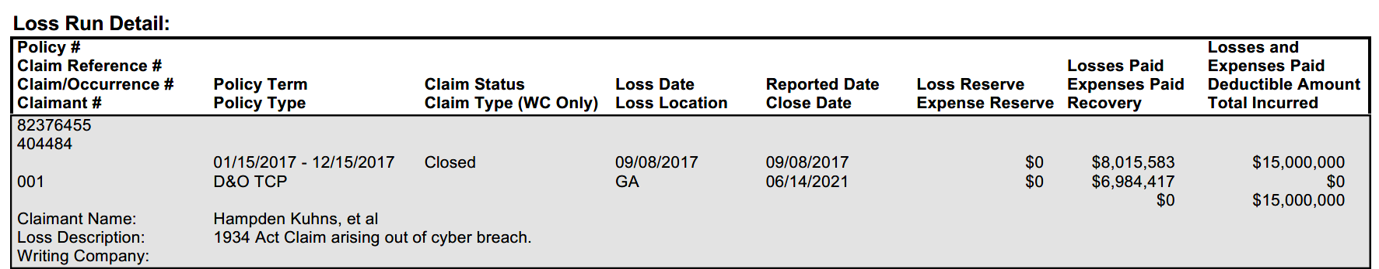
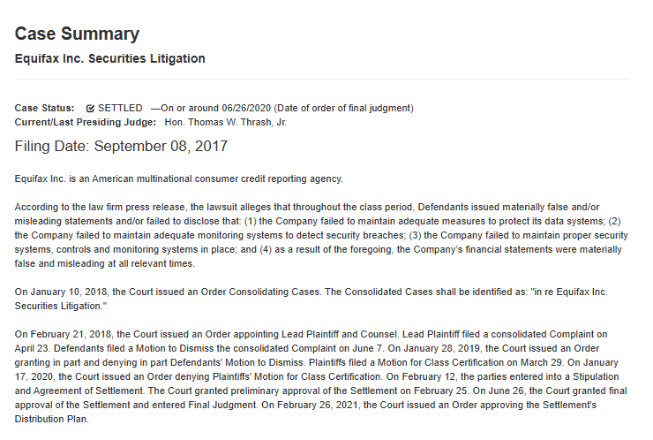
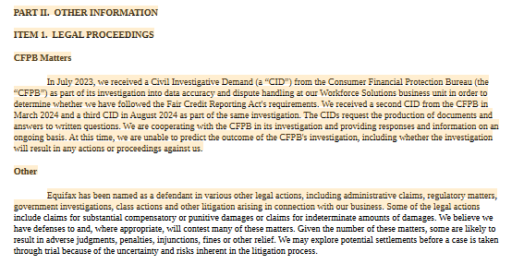
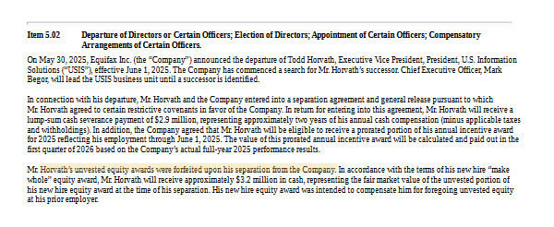
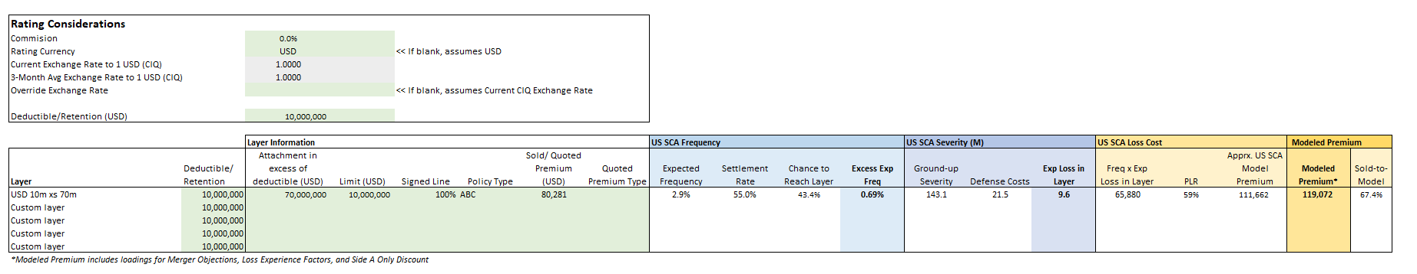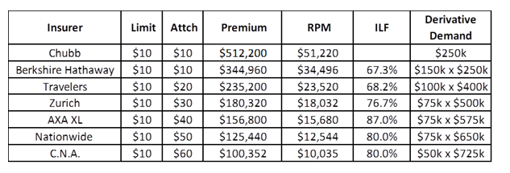
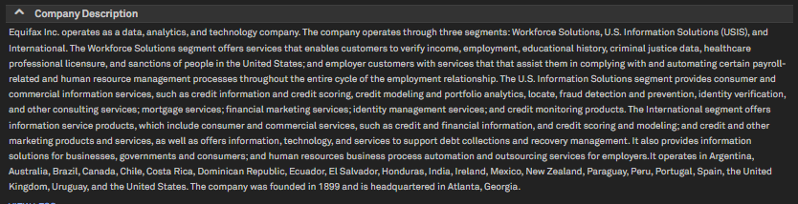
Equifax Inc. is a global data, analytics, and technology company headquartered at 1550 Peachtree Street, N.W., Atlanta, Georgia. The company specializes in providing information solutions to businesses, governments, and consumers, as well as human resources business process automation and outsourcing services for employers. Equifax collects and manages a wide array of data types—including credit, financial assets, telecommunications and utility payments, employment, income, educational history, criminal justice, healthcare professional licensure, demographic, and marketing data—to deliver customized insights and decision-making solutions using advanced analytics, machine learning, and proprietary software. Its operations are organized into three segments: Workforce Solutions (the largest, accounting for 43% of 2024 revenue), U.S. Information Solutions (USIS), and International, with significant activities in Australia, the U.K., and Canada. As of December 31, 2024, Equifax employed approximately 14,700 people across 22 countries and operated at least 62 physical locations (5 owned and 57 leased). Equifax is considered a global leader in its sector, with diversified revenue streams and a strong competitive position. In 2024, the company reported operating revenue of $5,681.1 million, operating income of $1,042.1 million, and net income attributable to Equifax of $604.1 million. International operations contributed 24% of consolidated revenue, with notable growth in Latin America, Europe, and Canada. The company maintains a broad network of subsidiaries and joint ventures, particularly in international markets, and has indefinitely invested $323.9 million in undistributed earnings of its Canadian and Chilean subsidiaries. Equifax’s products and services support credit and service decisions, risk management, payroll and HR process automation, and marketing strategies for clients in banking, brokerage, retail, insurance, mortgage, telecommunications, utilities, automotive, healthcare, and government sectors. Recent events and decisions include continued investment in cloud-native technology, machine learning, and AI to accelerate product development and delivery, as well as ongoing management of litigation related to the 2017 cybersecurity incident, with several Canadian class actions still pending. The company has adopted new accounting pronouncements and continues to make complex estimates affecting its financial statements. Equifax faces competition in fraud prevention, risk management, credit modeling, and analytics, emphasizing its decisioning technology and analytical capabilities as key differentiators. The leadership team is headed by CEO Mark W. Begor, with John W. Gamble, Jr. as CFO/COO, and a board of ten directors, nine of whom are independent. There have been no recent changes to executive leadership in 2025, though the board has seen planned refreshment with new directors added since 2020. Equifax’s business is highly dependent on maintaining key industry and technical certifications, which are critical for customer retention and new business acquisition.
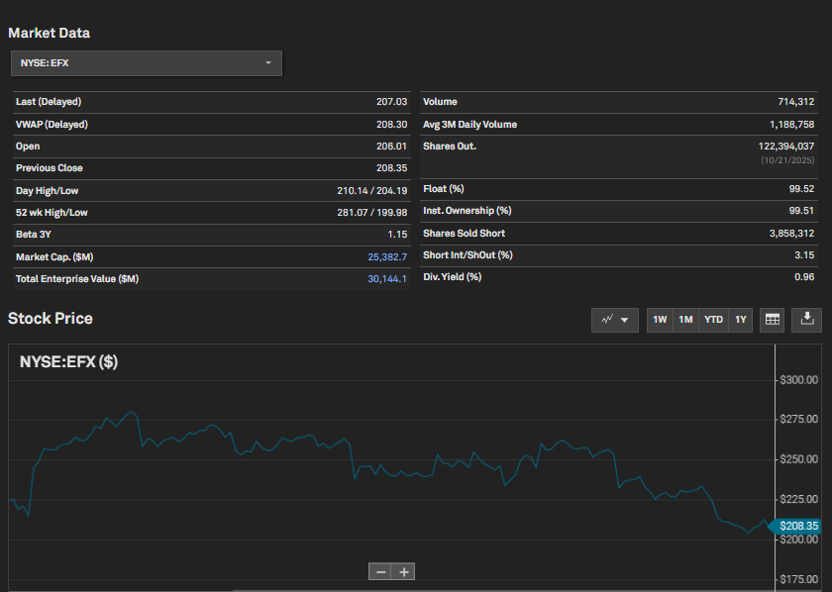

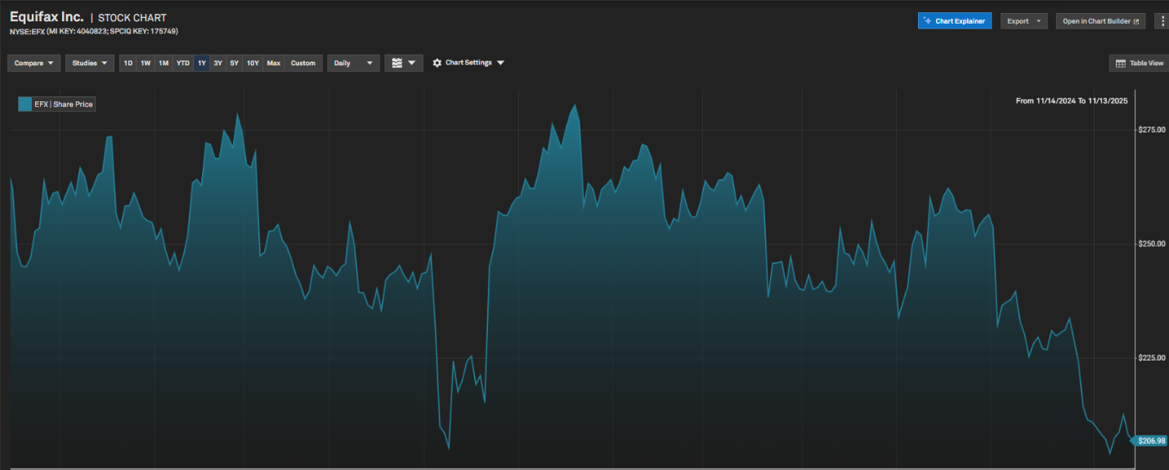
Key reasons for the stock price decline include:
- Litigation and Regulatory Penalties:
  - Equifax incurred significant legal and regulatory costs in the past year. Notably, the company paid a $13.5 million penalty to the U.K.'s Financial Conduct Authority (FCA) in October 2023 related to the 2017 cybersecurity incident, and a $15 million penalty to the U.S. Consumer Financial Protection Bureau (CFPB) in January 2025 for issues with its consumer disputes process and a coding error. These penalties, along with ongoing litigation, have increased expenses and heightened investor concerns about future liabilities and regulatory scrutiny.
  - Exact quote: "...paid a penalty of $13.5 million to resolve the matter. Additionally, in January 2025, the company entered into a consent order with the U.S. Consumer Financial Protection Bureau (cfpb) to settle investigations into its consumer disputes process and a coding issue, requiring the payment of a $15 million civil money penalty and modifications to certain business practices." (Annual Report, 2025-02-20, p. 15)
- Cybersecurity and Technology Risks:
  - The company continues to highlight technology and data security risks as a major concern. The transition to cloud-based infrastructure has exposed Equifax to additional cyber threats. The legacy of the 2017 breach and the risk of future incidents remain material, with the company stating that further breaches could result in substantial litigation, regulatory fines, and reputational damage.
  - Exact quote: "...we previously experienced a material cybersecurity incident in 2017 and if we experience additional breaches of our security measures... Any such access, disclosure or other loss of information could subject us to business interruption, significant litigation, regulatory fines or penalties, any of which could have a material adverse effect on our cash flows, competitive position, financial condition or results of operations..." (Annual Report, 2025-02-20, p. 15)
- Economic and Sector-Specific Headwinds:
  - Equifax operates in a high-tech sector sensitive to macroeconomic conditions. The company reported rising operating expenses (up 7% in Q3 and 6% for the nine months ended September 30, 2025), driven by higher royalty, revenue share, purchased data costs, people costs, and litigation expenses. Economic uncertainty, lower GDP growth, and declining mortgage credit activity have also pressured revenue, especially in mortgage-related services.
  - Exact quote: "Operating expenses increased by 7% in Q3 and 6% for the nine months, driven by higher royalty, revenue share, purchased data costs, people costs, and litigation expenses." (Quarterly Report, 2025-10-21, p. 2)
- Foreign Exchange Impacts:
  - Revenue growth was negatively affected by foreign currency fluctuations, particularly in Latin America and Asia Pacific, reducing reported growth and contributing to volatility.
  - Exact quote: "Revenue was negatively affected by foreign currency fluctuations, particularly in Latin America and Asia Pacific, reducing reported growth." (Quarterly Report, 2025-10-21, p. 2)
- Leadership Changes:
  - The departure of Todd Horvath, President of U.S. Information Solutions, effective June 1, 2025, may have contributed to uncertainty about future strategic direction and leadership stability.
  - Exact quote: "On May 30, 2025, Equifax Inc. announced the departure of Todd Horvath, who was executive vice president, president, U.S. Information Solutions (usis), effective June 1, 2025. The company has commenced a search for his successor..." (Current Report, 2025-05-30, p. 1)
- Market Volatility and Investor Sentiment:
  - The company acknowledges that adverse publicity from cybersecurity incidents, regulatory actions, or litigation can negatively impact its reputation and customer relationships, which in turn affects investor confidence and stock performance.
  - Exact quote: "Cybersecurity incidents, and the adverse publicity that may follow, can have a negative impact on our reputation and our relationship with our customers..." (Annual Report, 2025-02-20, p. 28)
In summary, Equifax's stock price drops over the past year have been driven by a combination of regulatory penalties, ongoing litigation, cybersecurity risks, rising expenses, economic headwinds, foreign exchange impacts, leadership changes, and negative investor sentiment. These factors are well-documented in the company's recent filings and have contributed to periods of significant share price volatility.

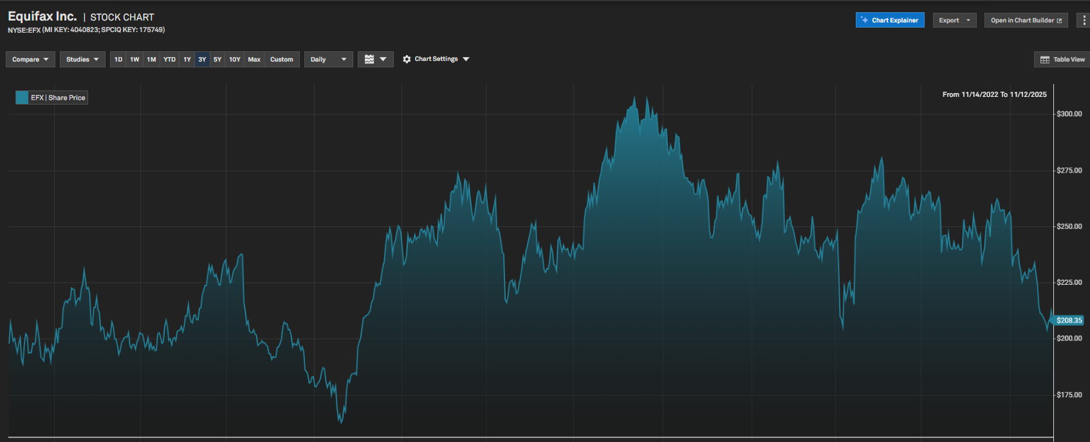
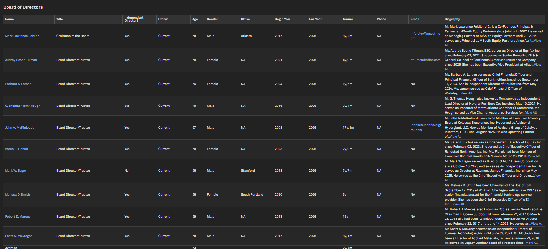
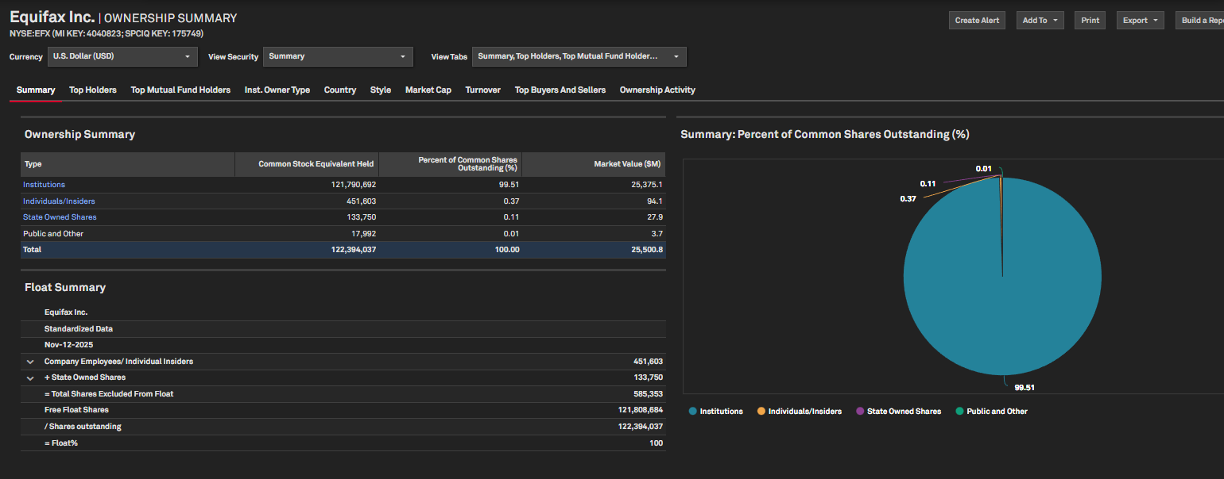
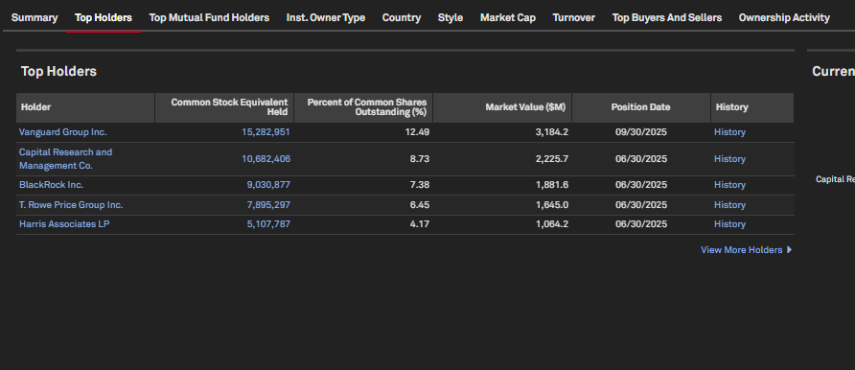
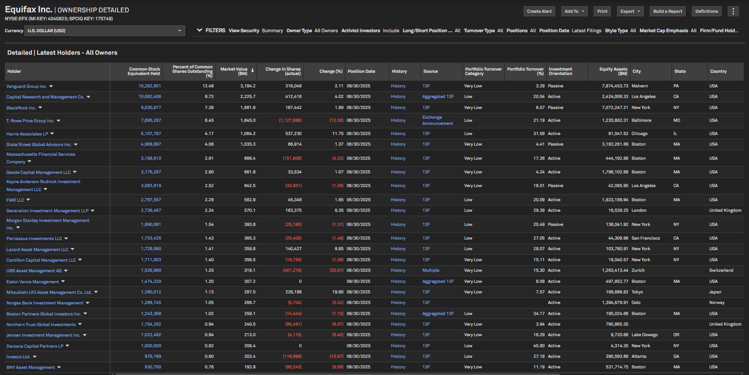
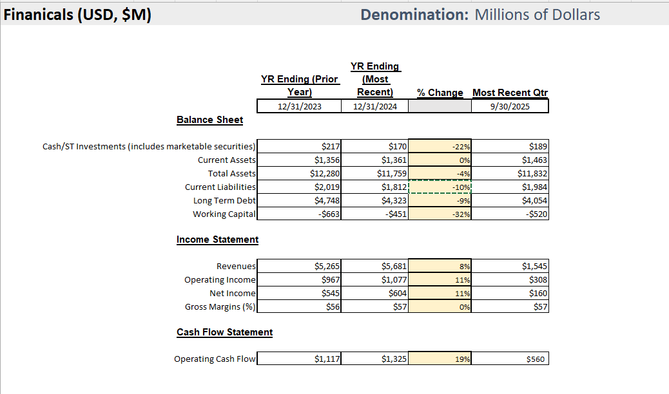

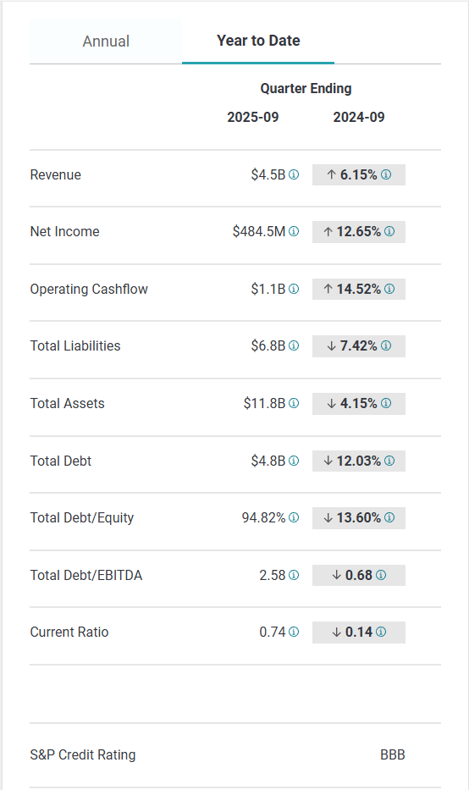
Financial Comments -
- Third quarter 2025 revenue of $1.545 billion up 7% and $25 million above the midpoint of Guidance, despite headwinds from U.S. Hiring and Mortgage markets.
- Third quarter U.S. Mortgage revenue up a strong 13% despite decline in underlying Mortgage market.
- Workforce Solutions third quarter revenue up 5%. Verification Services revenue up 5% led by strong high single digit Government growth, with Non-Mortgage growth of 7% and Mortgage growth of 2%.
- USIS third quarter revenue up 11% with strong Mortgage revenue growth of 26% and Non-Mortgage revenue growth of 5%.
- International third quarter revenue up 6% on a reported basis with 7% growth on a local currency basis led by Latin America and Canada.
- Raising full year 2025 Vitality Index to 13%, above our 10% long-term goal, from strong 16% Vitality in the quarter leveraging new EFX Cloud and EFX.AI with double digit Vitality Index across all business units.
- Returned approximately $360 million of cash to shareholders, including repurchasing 1.2 million shares for $300 million.
- Raising 2025 Guidance given strong third quarter results. Increasing full-year reported revenue by $40 million and Adjusted EPS by $0.12 per share.
- Increased 2025 free cash flow Guidance from $900+ million to $950 million to $975 million from strong operating performance.
- Introduced new Mortgage Scores pricing structure to support a competitive credit scoring market and reduce mortgage costs for American homebuyers and the mortgage industry
- The Company reported revenue of $1,544.9 million in the third quarter of 2025, up 7% on both a reported and local currency basis compared to the third quarter of 2024.
- Net income attributable to Equifax of $160.2 million was up 13% in the third quarter of 2025 compared to $141.3 million in the third quarter of 2024.
- Diluted EPS attributable to Equifax was $1.29 per share in the third quarter of 2025, up 14% compared to $1.13 per share in the third quarter of 2024.

Financial Results
- Total revenue in the recent quarter was $1.54 billion, representing a 7% YoY increase in both constant currency and reported dollars.
- Adjusted EPS reached $2.04 per share, surpassing the prior guidance midpoint by $0.12; adjusted EBITDA margin was 32.7%, up 20bps QoQ.
- U.S. mortgage revenue grew 13% YoY; USIS segment revenue increased 11%, exceeding its 6–8% long-term growth framework.
- International revenue rose 7% YoY in constant currency; international adjusted EBITDA margins improved by 360bps YoY.
- Equifax returned $360 million to shareholders, including $300 million in repurchases (1.2 million shares, ~1% outstanding).
Outlook
- Full year revenue guidance midpoint raised by $40M; total revenue now expected up 6.1–6.7% versus prior year.
- Full year adjusted EPS guidance increased by $0.12; projected growth now at 3.6–5% year-over-year.
- Free cash flow for the full year expected between $950M and $975M, with cash conversion over 100%.
- Workforce Solutions revenue projected up mid-single digits; adjusted EBITDA margins expected at 51–51.3%.
- Long-term financial framework targets 7–10% organic revenue growth and 50bps EBITDA margin expansion annually under normal conditions.
Company Strategy
- Equifax is leveraging its completed Cloud transformation, single data fabric, and EFX.AI to drive innovation and new product growth.
- Restructuring actions and global operational streamlining aim to deliver $30M annual cost savings by late 2026, improving efficiency.
- Accelerated rollout of VantageScore 4.0 in mortgage credit scoring is expected to save customers up to $200M and boost market competition.
- Equifax is focused on expanding government solutions, targeting untapped state markets and developing tools to reduce fraud and improper payments.
- Multi-data asset solutions, combining credit and income indicators, are being deployed in verticals like mortgage and auto to drive share gains.
External Factors
- Lower mortgage rates in the recent quarter drove stronger market volumes, supporting USIS revenue outperformance vs. expectations.
- Inflation moderating and declining rates are expected to improve long-term mortgage activity, returning closer to historical norms.
- U.S. hiring remained weak with white collar BLS data down 4%, impacting onboarding revenue and signaling ongoing labor market softness.
- Government regulation changes, including the OB3 bill, increased demand for verification services, presenting growth opportunities for EWS.
- Federal government shutdown risk is present; guidance assumes no material impact, but extended shutdown could defer government-related revenue.
Products & Services
- Equifax is investing heavily in EFX.AI to enhance scores, models, and products, targeting cost savings and greater accuracy.
- AI-powered solutions yield 10-point lifts in identity and underwriting scores, leveraging differentiated Equifax data.
- VantageScore is driving customer engagement, offering significant savings versus FICO, with incentives tied to conversions.
- Ignite analytics engine is being enhanced with AI capabilities to increase adoption and analytics delivery.
- TWN instant solution is now integrated to provide a complete credit picture, including employment verification.

Key Financial Highlights:
- Revenue and Profitability:
- For the year ended December 31, 2024, Equifax reported operating revenue of $5,681.1 million, an 8% increase over 2023 ($5,265.2 million). Operating income was $1,042.1 million, up 12% from $933.6 million in 2023. Net income attributable to Equifax was $604.1 million, up 11% from $545.3 million in 2023. Diluted EPS for 2024 was $4.84, up from $4.40 in 2023. (Annual Report, 2025-02-20, p. 35)
- Quarterly Performance:
- In Q3 2025, operating revenue was $1,537.0 million (up 7% YoY), operating income was $310.8 million (up from $282.2 million in Q3 2024), and net income attributable to Equifax was $191.3 million (up from $163.9 million in Q3 2024). Diluted EPS for Q3 2025 was $1.53, up from $1.31 in Q3 2024. (Quarterly Report, 2025-07-22, p. 3)
- Segment Performance (First Six Months of 2025):
- Workforce Solutions revenue grew 5% (Verification Services up 8%, Employer Services down 5%). U.S. Information Solutions revenue grew 8%. International revenue grew 2%, with Europe up 7%, Latin America up 3%, Asia Pacific up 1%, and Canada down 2%. (Quarterly Report, 2025-07-22, p. 14)
- Cash Flow and Liquidity:
- For the nine months ended September 30, 2025, cash provided by operating activities was $1,144.9 million (up from $999.7 million in 2024). Capital expenditures were $351.4 million (down from $392.6 million in 2024). Cash and cash equivalents at the end of Q3 2025 were $189.0 million. (Quarterly Report, 2025-10-21, p. 7)
- Capital Management:
- Debt levels decreased by 12% year-over-year, and interest expense declined. The company authorized a $3 billion share repurchase program and increased its quarterly dividend to $0.50 per share. (Annual Report, 2025-02-20, p. 35; Quarterly Report, 2025-07-22, p. 3)
- Audit Opinion:
- Ernst & Young LLP issued an unqualified opinion on both the financial statements and internal controls for the year ended December 31, 2024. (Annual Report, 2025-02-20, p. 57)
- Risks and Challenges:
- Operating expenses increased by 7% in Q3 and 6% for the nine months, driven by higher royalty, revenue share, purchased data costs, people costs, and litigation expenses. Economic uncertainty and foreign currency fluctuations (notably in Latin America and Asia Pacific) negatively impacted reported revenue. (Quarterly Report, 2025-10-21, p. 23)
Summary: Equifax Inc. demonstrates strong financial performance with consistent revenue and profit growth, improved margins, and disciplined capital management. The company maintains solid liquidity and has reduced its debt burden. However, it faces challenges from rising costs, economic uncertainty, foreign exchange volatility, and ongoing litigation/regulatory risks. Management is focused on innovation, shareholder returns, and strategic adaptation to mitigate these risks.

